Integers- Temperature and Elevation
  - My learning goals
1. I can use positive and negative numbers to indicate a change
2. I can describe real situations using integers and represent them on a number line
3. I can choose an appropriate scale for the number line when given a set of positive and negative numbers to graph

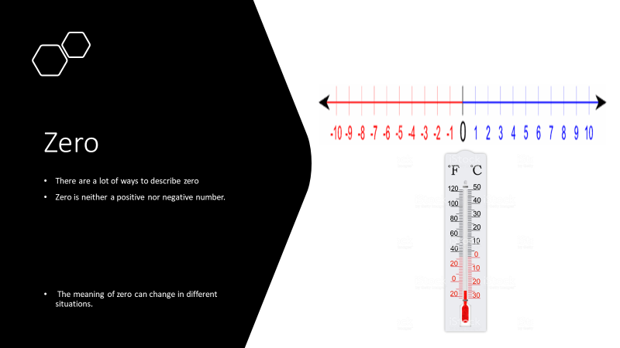

What does Zero mean to you…. nothing, naught, nada, nil, zip, zilch, empty, goose egg are just a few descriptions
Zero separates the positive and negative integers.
Now think about zero on a thermometer.
Zero represents the point when things begin to freeze
How would you describe zero on the thermometer?
In real-life situations, zero can represent many things. When looking at the ocean, zero represents sea level and things above sea level are written with positive integers and things below sea level are written using negative integers.
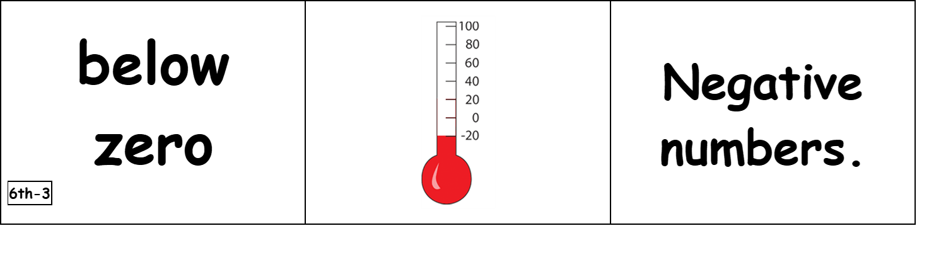
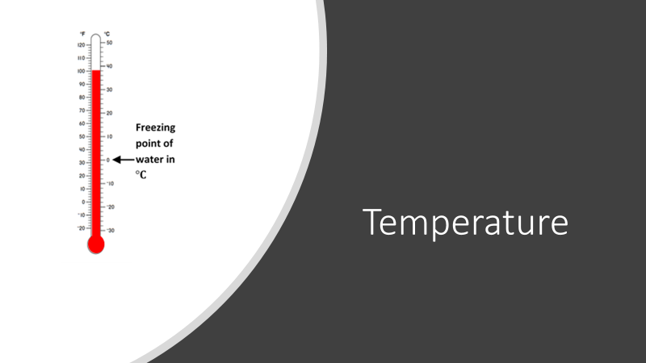

$-10℃$ can be read as “negative ten degrees Celsius.” It can also be read as “ten degrees below zero.” However, it should not be read as “negative ten degrees below zero.”
Temperatures that are above zero can be stated as their numerical value. For example, describing a fever of $102℉$ can be simply stated as “one hundred two degrees.”

Before you go on:
- Watch a video about Fahrenheit and Celsius: https://www.youtube.com/watch?v=HKQKjbdYNkA

Try Temperature practice problems (click the button on the Discovery webpage).

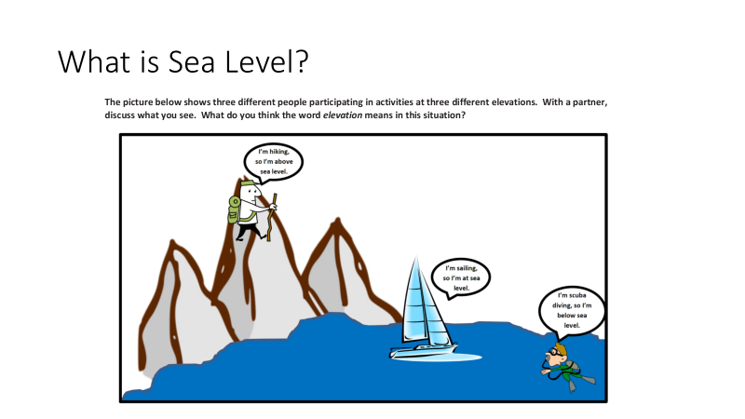
Looking at the picture, if you were to draw a vertical number line to model elevation, which person’s elevation do you think would be at zero? Explain.
Sea level should represent an elevation of zero. So, the person sailing would be at zero because he is sailing on the surface of the water, which is neither above nor below the surface. On a number line, zero is the point or number separating positive and negative numbers.
On the same vertical number line, which person’s elevation would be represented above zero?
The elevation of the person hiking would be above zero because she is moving higher above the water. On a vertical number line, this is represented by a positive value above zero because she is above the surface.
On the same vertical number line, which person’s elevation do you think would be below zero?
The elevation of the person scuba diving would be below zero because he is swimming below the surface of the water. On a vertical number line, this is represented by a negative value below zero because he is below the surface.
What does zero represent in this situation?
Zero represents the top of the water (the water’s surface).
In this example, which numbers correspond to elevations above sea level?
Above sea level means to be above zero, which are positive numbers.
In this example, which numbers correspond to elevations below sea level?
Below sea level means to be below zero, which are negative numbers.
On a number line, what does it mean to be at sea level?
To be at zero means to be at sea level.
Elevation is the height of a person, place, or thing above or below a certain reference point. In this case, what is the reference point?
The reference point is sea level.

Now Try some practice problems: click on the Elevation problem sets on the website
For an extra challenge try: the Real-Life Integer worksheet

