Integers- Gains and Losses

* + My learning goals

1. I can use positive and negative numbers to indicate a change (gain or loss)

2. I can describe real situations using integers and represent them on a number line

3. I can choose an appropriate scale for the number line when given a set of positive and negative numbers to graph.

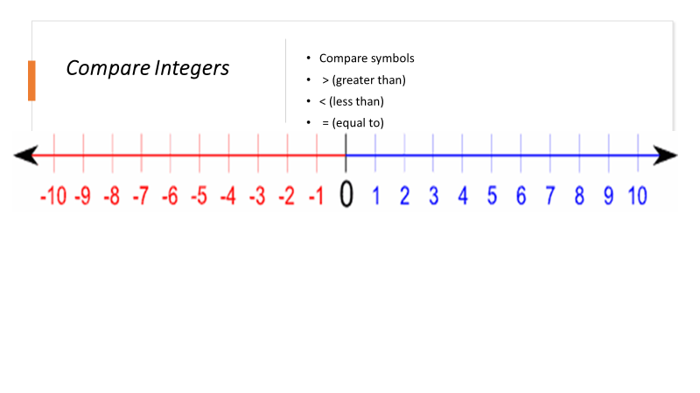

What patterns do you see with the numbers on the number line?

*For each number to the right of zero, there is a corresponding number the same distance from zero to the left.*

What does zero represent on the number line?

*Zero represents the reference point when locating a point on the number line. It also represents the separation of positive numbers from negative numbers.*

What is the relationship between any two opposite numbers and zero on the number line?

*Opposite numbers are the same distance from zero, but they are on opposite sides of zero.*

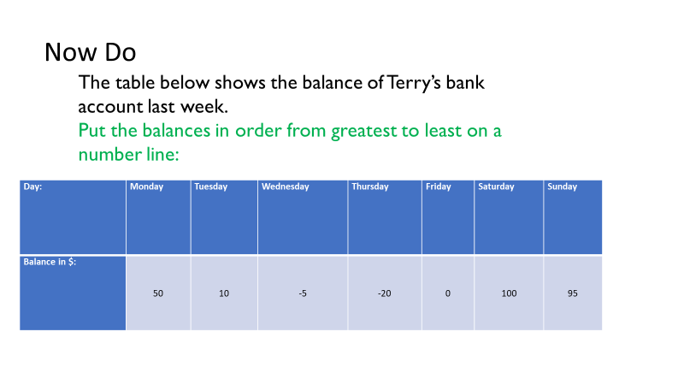

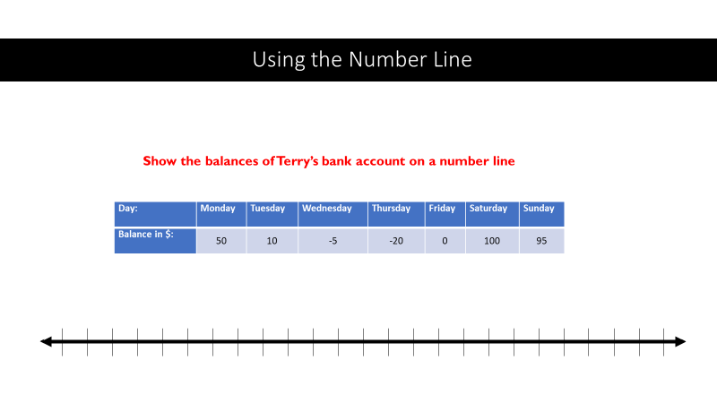

How would you show $150$ on a number line?

What strategy would you use to number the number line in order to show $150$?

*I would locate (place) zero as far to the left as possible and use a scale of $10$.*

*I could also label the first tick mark $140$ and count by ones.*

If you want to have zero and $150$ on the given number line, what scales would work well (what should you count by)?

*I could count by fives, tens, or twenty-fives.*

**It Is important to use** **an appropriate scale.**

Pay careful attention that you don’t:

**Mark Unequal intervals**—Intervals should be equal **from one mark to the next**. This usually happens when students stop skip-counting in order to make the numbers fit on the diagram (e.g $.$, $5$, $10$, $15$, $20$, $50$, $100$, $150$).

**Miscount**—This is usually the result of rushing and not paying attention to details. Always **check your scales for accuracy before plotting** points.

**Starting at zero**—The problem should **determine the appropriate start and end point for a number line**. C**ount the number of tick marks (lines) first in order to determine a starting point.**

Use the only part of the number line—Spacing should be evenly distributed throughout a number line. This usually happens when you are counting by a value that is too large (e.g., counting by tens instead of twos).

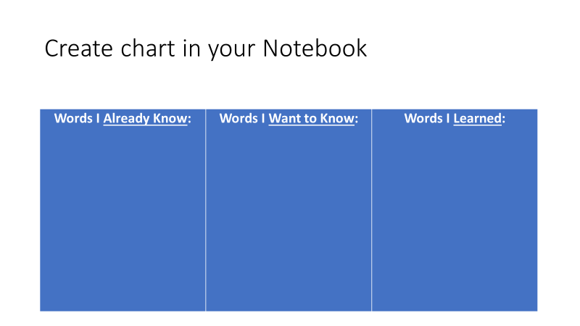

In the story problem below, you will see examples of how negative and positive numbers can be used to represent real-world situations involving money. Read the story problem below. Make notes in your chart of words you know or that are new that you want to know…

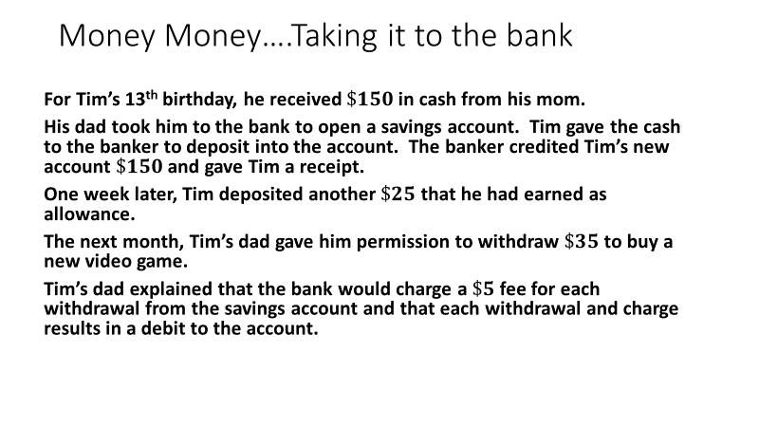

Did you notice the words deposit, credited, debit, and withdraw/withdrawal? These are basic financial vocabulary words.

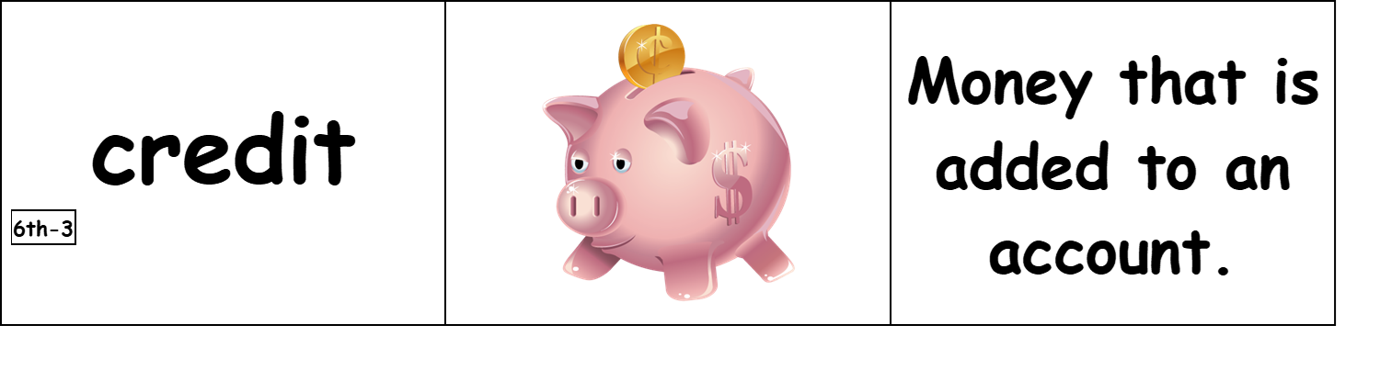

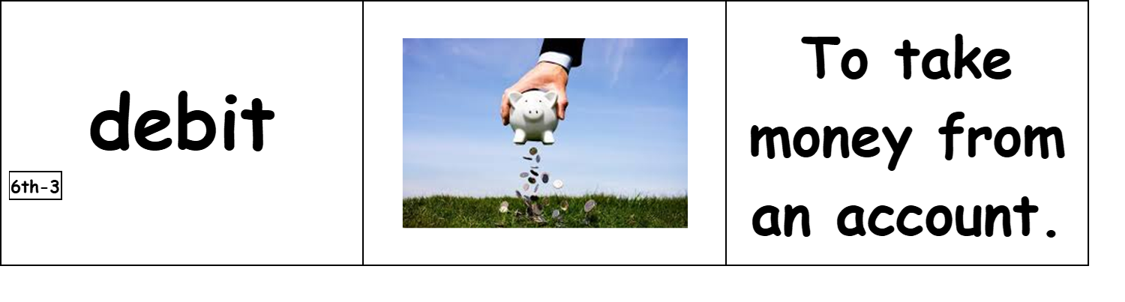

So, now let’s look at the word problem using integers and our number line.

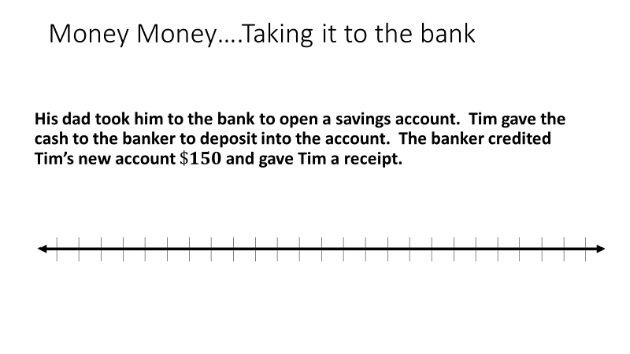

Tim receives $\$150$ for his birthday. Do you think this will be a positive or negative number for Tim’s money? Explain.

*Positive; $\$150$ is a gain for Tim’s money. Positive numbers are greater than $0.$*

How much money is in the account when Tim opened it? What does this number represent in this situation?

*The account has $\$0$ in it because Tim had not put in or taken out any money. Zero represents the starting account balance.*

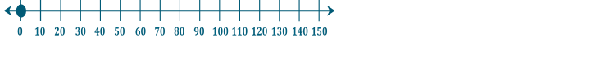

The $\$150$ that Tim gives the banker is called a *deposit*. A deposit is the act of putting money into a bank account. To show the amount of money in Tim’s savings account, would this deposit be located to the left or right of zero on the horizontal number line?

*This deposit is located to the right of zero because it increases the amount of money in the savings account.*

The bank credited the account $\$150$. A *credit* is when money is deposited into an account. The account increases in value. How would you represent a credit of $\$150$ as an integer? Explain.

*Since a credit is a deposit and deposits are written as positive numbers, then positive $150$ represents a credit of $\$150$.*

Thus, the graphing of Tim’s account after the deposit looks like this:

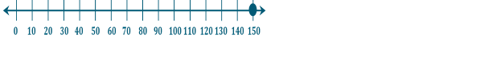

Now let’s look at what Time does next:

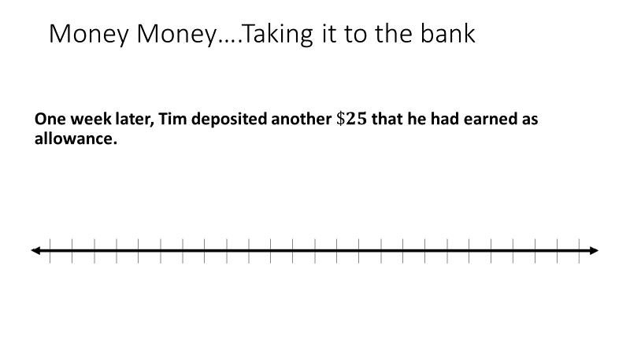

Tim makes another deposit of $\$25$. Would this be a positive or negative number for Tim’s savings account, and how would you show it on a horizontal number line?

*A deposit increases the amount of money in the savings account, so $25$ is positive. I would place the point $25$ units to the right of zero.*



And the story continues….

**The next month, Tim’s dad gave him permission to withdraw $\$35$ to buy a new video game.**

**Tim’s dad explained that the bank would charge a $\$5$ fee for each withdrawal from the savings account and that each withdrawal and charge results in a debit to the account.**

The bank creates a debit of $\$5$ for any withdrawal. What do you think the word *debit* means in this situation?

*A debit sounds like the opposite of a credit. It might be something taken away. Taking money out of the savings account is the opposite of putting money in.*

A debit means money paid out of an account. It is the opposite of a credit. Are debits represented as positive or negative numbers on the horizontal number line for the amount of money in a savings account?

*A debit is represented as a negative number to the left of zero on a number line because debits are the opposite of credits, which are positive numbers.*

The bank charges a $\$5$ service fee for any withdrawal from a savings account. A *charge,* also called a *fee,* is the amount of money a person has to pay for something. Can you name a situation where you would have to pay a charge?

*I would have to pay a charge at an amusement park, a concert, a basketball game, or a doctor’s office.*

How would you represent a charge of $\$5$ for Tim’s savings account on the horizontal number line?

*A charge of $\$5$ would be $-5$ because money is being taken out of the account. I would find positive five on the number line by starting at $0$ and moving $5$ units to the right. Then, I would count $5$ units going left of zero to end at $-5$.*

Tim withdrew $\$35$ from his account. Based on the story problem, what is the meaning of the term *withdraw*?

*Since Tim wanted to buy something, he took money out of the account. I think withdraw means to take money out of an account.*

To withdraw money is to take money out of an account. How would you represent the $\$35$ for the video game as an integer for Tim’s savings account?

*The money was taken out of Tim’s account; it would be represented as $-35$.* 

So, now it’s your turn to try! Click on Integers- Gains and Losses practice set