Name:
Date:
Marble Billiards Demonstration Instructions.

Explain your answers to the questions (below) with your Marble Billiards set-up.
You must have your answers written on index cards before you may demonstrate to a teacher.

- How do you think Newton’s laws will help explain marble billiards? You may use this illustration below to help you get started for how you will explain.

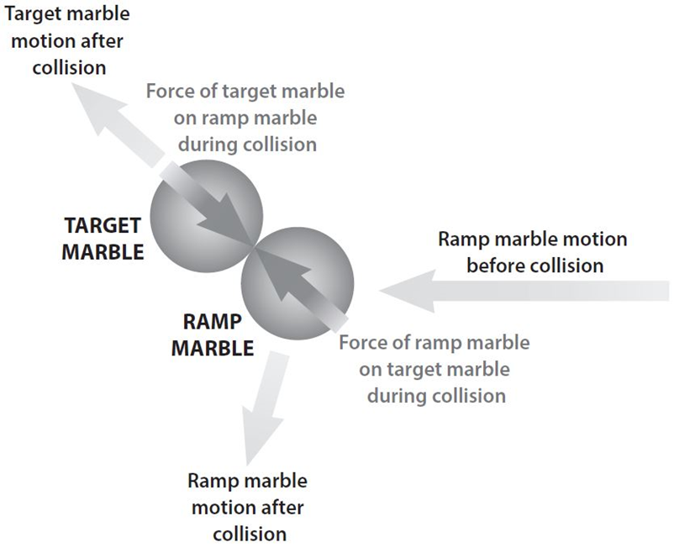

- How do Newton’s laws help us explain what was happening during the collision of the marbles?

- How did you get the target marble moving in the right direction to go through the goal?

- What determined the direction that the target marble moved after the collision?

- Newton’s 1st law tells us that if the target marble started moving, a force was applied to it. What object applied force on the target marble?

- When the ramp marble hit the target marble, did the ramp marble keep going in the same direction?

