Olympic Task 1
Day One
Research Question: What is the history and mythology of the ancient Greek Olympics?
Begin by writing the above question in your social studies notebook.
Next, make two columns labeled: Mythology and History.
Find the meaning of each of those words and write them in your notebook.
Lastly, use the resources below and your “Power Note-taking" skills to take notes.
You will be using these notes in your work tomorrow.
https://www.bbc.co.uk/bitesize/topics/z87tn39/articles/z36j7ty
https://www.youtube.com/watch?v=VdHHus8IgYA

How did the Olympic Games begin?
Part of
History
Ancient Greece
Add to My Bitesize
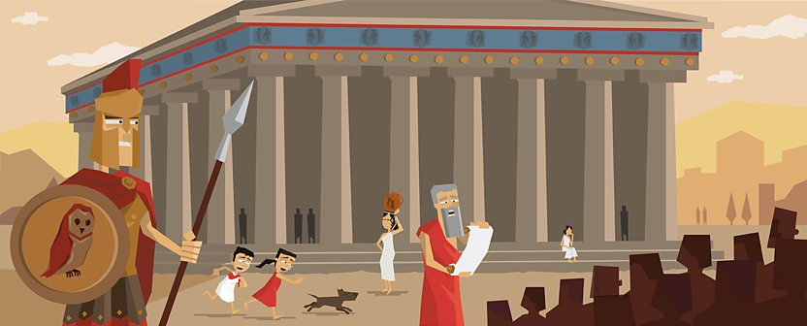
The Greeks loved sport and the Olympic Games were the biggest sporting event in the ancient calendar.
The Olympic Games began over 2,700 years ago in Olympia, in south west Greece. Every four years, around 50,000 people came from all over the Greek world to watch and take part. The ancient games were also a religious festival, held in honour of Zeus, the king of the gods.
There were no gold, silver and bronze medals. Winners were given a wreath of leaves and a hero's welcome back home. Athletes competed for the glory of their city and winners were seen as being touched by the gods.

A truce for the sacred games
Before the games began, messengers were sent out to announce a 'sacred truce' or a peace. This meant that any wars should be called off so that people could travel safely to Olympia.
The entire games were dedicated to Zeus. Visitors flocked to see the Temple of Zeus. Inside stood a huge gold and ivory statue of the king of the gods himself.
The main event at the Olympics was not a sporting event, but a sacrifice. On the third day of the games, 100 oxen were sacrificed and burnt on the Altar of Zeus.
This altar was not made from stone. Instead it was made from the leftover ash of all the sacrificed oxen. By around 200AD, the mound of ash stood six meters high!
The ancient Olympics wasn't just about the sport, it was a religious festival too. Find out what it was like to visit the ancient games.
Click on the athletes below to find out more about some of the sporting events at the ancient games.

Women at Olympia
Only men, boys and unmarried girls were allowed to attend the Olympic Games. Married women were barred.
If they were caught sneaking in, they could be thrown off the side of a mountain as punishment!
However, women could still own horses in the chariot races at the Olympics and unmarried women had their own festival at Olympia every four years.
This was called the Heraia and was held in honour of Hera, Zeus's wife. Winners were awarded crowns of sacred olive branches, the same as men. But in ancient Greece, only Spartan women were really interested in sport.
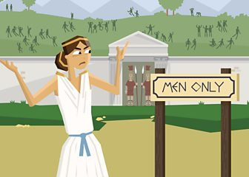
Married women were not allowed at the Olympic Games. However, one story tells of a mother so keen to see her son compete that she broke the no-women rule and got in disguised as a man.

Take a tour of Olympia
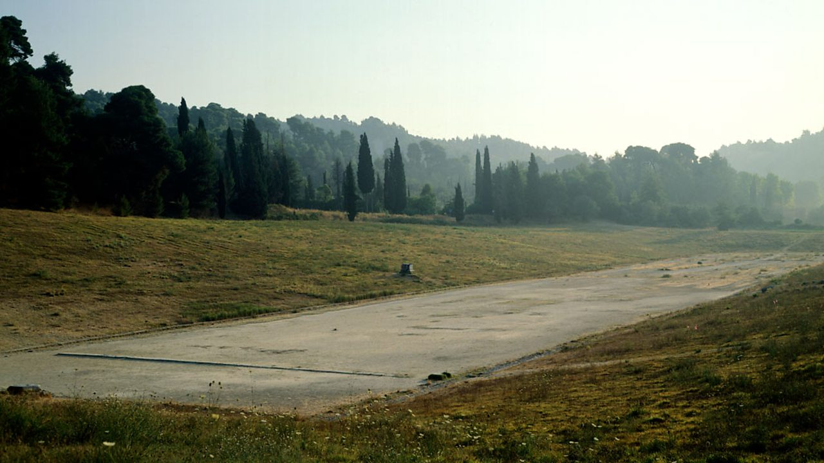
This is the stadium at Olympia. It was built during the 4th century BC and it was the largest of its kind at the time. It could seat 50,000 spectators!
1 OF 5
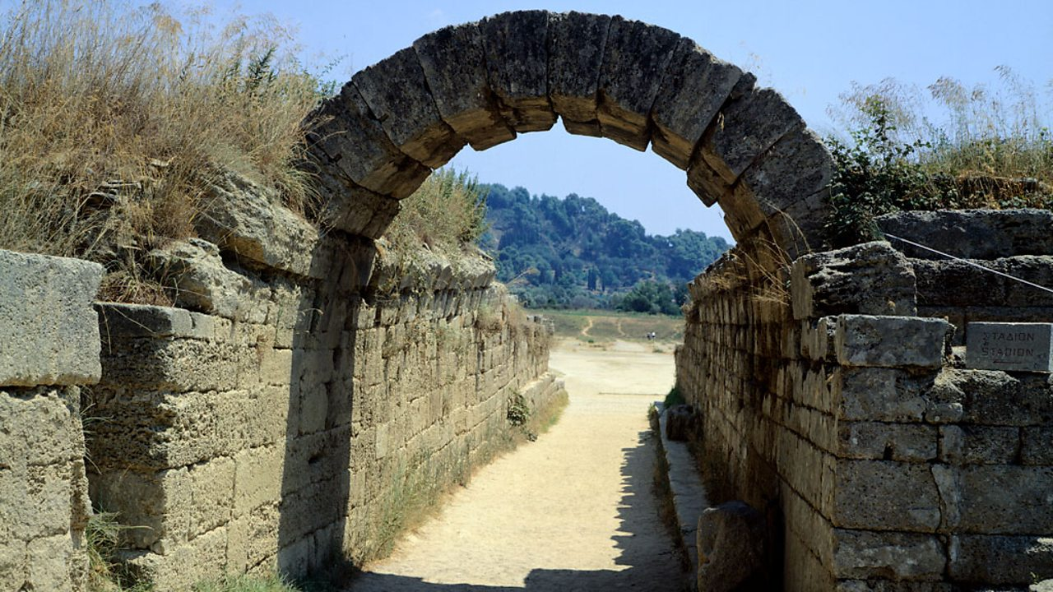
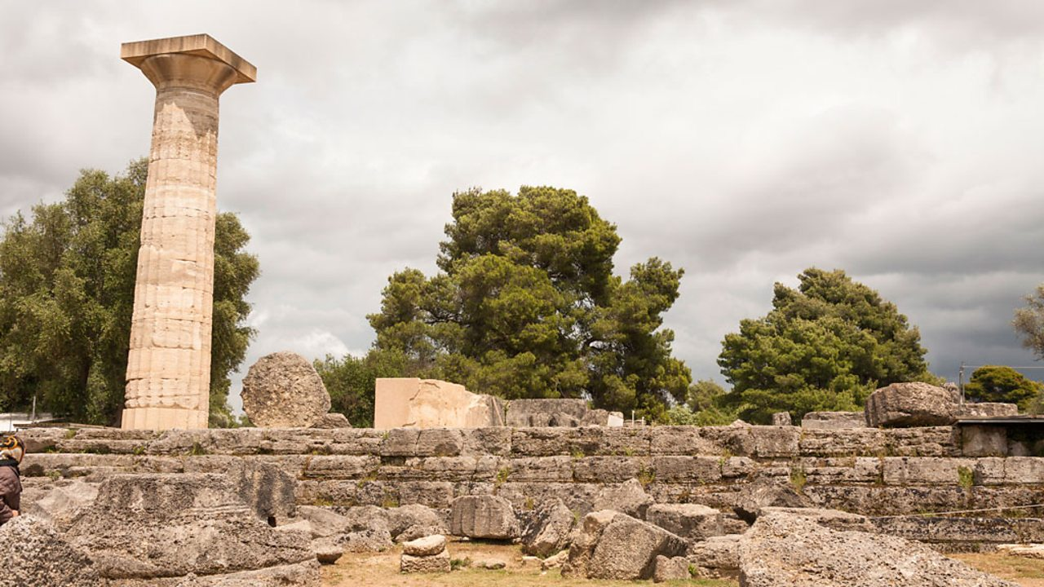
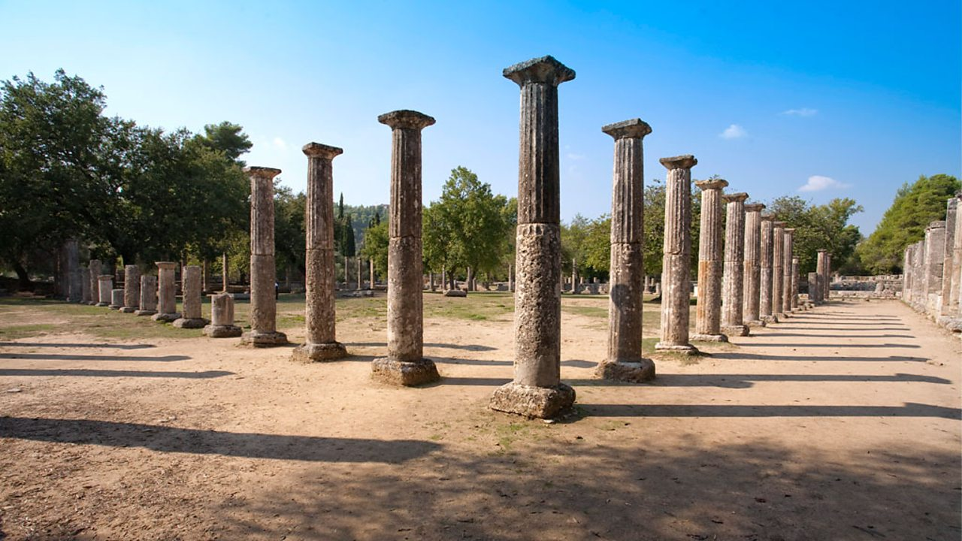
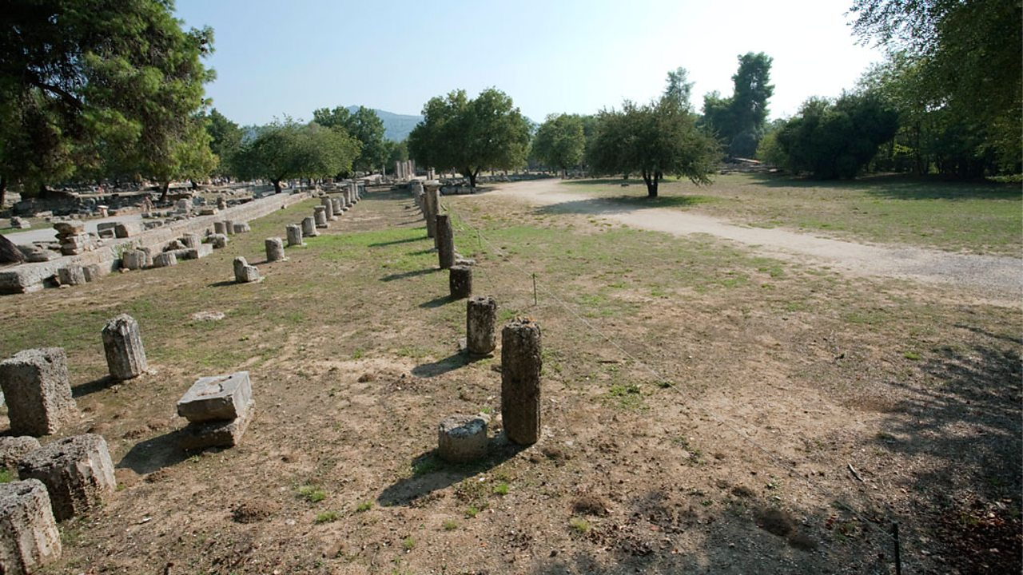

Play Bitesize games
Level up now! Take on the latest primary games on Bitesize.

There's more to learn...

Who were the ancient Greeks?
This guide
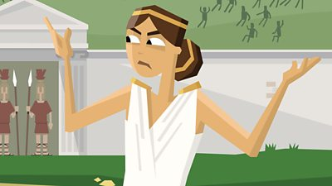

How did the Olympic Games begin?
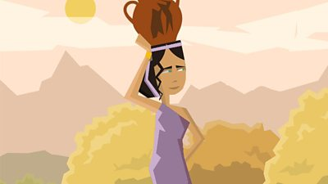

What was it like to live in an ancient Greek family?
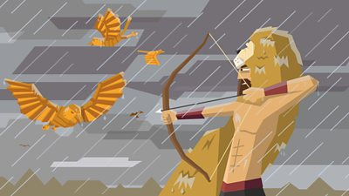

Who were the ancient Greek gods and heroes
Up next
What was it like to live in an ancient Greek family?

